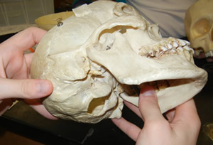
The Mystery of the Bones (Part I)

Objectives
- Understand what a forensic anthropologist does
- Reconstruct 4 "unknown" skeletons
- Determine the age, sex, height of the "unknowns"
- Investigate forensic art and its application in finding missing persons
- Determine the identities of the 4 "unknowns"

Section 1 - Research and Background
As a group, visit the following sites to gain an understanding of forensic anthropology and what bones (or remains) can tell you about the deceased. Be prepared to take a quiz (as a group) when you are finished. Write all answers on a separate page, you can turn in a single page for your entire group.
Investigative Techniques of Forensic Anthropology (http://www.pbs.org/opb/historydetectives/techniques/forensic_feature.html)
Mouse over the skeleton to answer these..
1. What can the teeth tell you about the deceased?
2. How can the skull be used to determine age?
3. How is the pelvis of a female different from the pelvis of a male?
4. The hand bones can help you determine what about the deceased?
Explore Forensics ( http://www.exploreforensics.co.uk/ ) - most can be found at the link: Analyzing the body
1. What is the first thing a forensic scientist looks at to identify a deceased?
2. Where is the most accurate place to take the body temperature? Suppose a body is found and its temperature is recorded at 34 degrees celcius, how long has the body been dead?
3. Why might a corpse be exhumed?
4. What insect is used to determine time of death? What type of scientist studies these insects?
5. What is rigormortis and how long does it last?
6. What is lividity?
7. What are the four categories of death?
Written in Bone - Exhibit at the Smithsonian ( http://anthropology.si.edu/writteninbone/index.html )
Skeleton Keys --> Bone Basics
1. What is the last bone to complete its growth?
2. How are teeth used to estimate age?
3. What is bone "remodeling" and how can it be used to determine age?
4. What is the sciatic notch? How can it be used to determine gender?

Forensic Case Files
5. Browse the cases and choose one that interests you. Describe the case and the key evidence used to solve it.
STOP: TAKE THE QUIZ TO BECOME A LICENSED WEB FORENSIC ANTHROPOLOGIST
When you have reviewed all of the links and feel confident (know the answers to the questions) see your teacher to get the quiz. You will take the quiz as a group to receive your "Medical Examiner License" that will allow you to proceed to the next section.
Proceed to Section 2 - The Crime Scene

Webquest: Mystery of the Bones (Part II)

The Scene
In a quiet camping area known as Crystal Lake, four complete human skeletons were found in the mud when the lake began to dry during a drought. Detectives checked the missing person's reports for people in the area and found that five people had disappeared from that area over the last 10 years.
Oddly, the skeletons were almost completely intact due to being somewhat preserved in the clay at the bottom of the lake.
~ Author's Note: These are ficticious characters in a ficticious crime scene

Crystal Lake
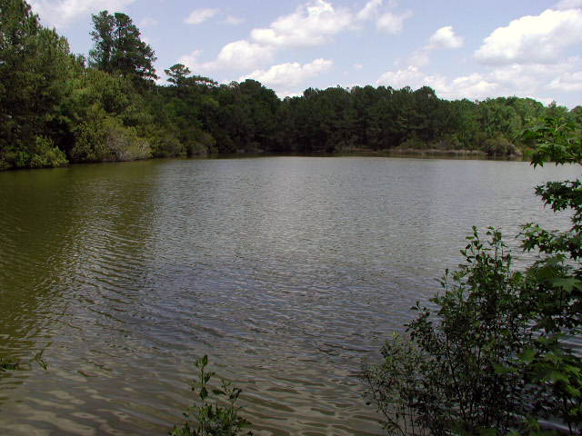

Photos of Remains Found There
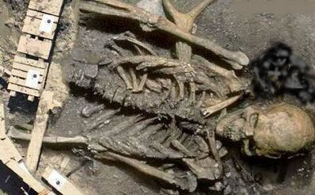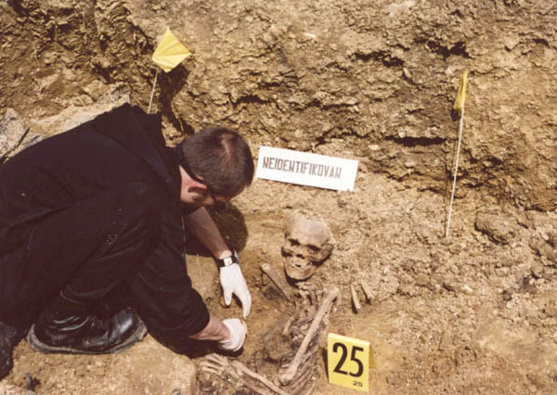
Evidence Files Instructions
1. Each team member should pick a bone set and reconstruct the skeleton using glue, scissors and tape.
2. Each bone of the skeleton should be labeled
3. Next you will need to determine the identity of the bones based on age and height
a. Determine the gender of your subject by looking at the shapes of specific bones
b. Use the following formula to determine the height of your subject
Your "paper" skeleton is not a real skeleton. Assume that 1cm on your paper skeleton = 8.6 cm on the real skeleton
Male (real) | (2.32 x length of the femur in cm.) +65.53 ± 3.94
Female (real) | (2.47 x length of the femur in cm.) + 54.10 ± 3.72
Feet to Cm height conversion (http://www.manuelsweb.com/ft_in_cm.htm)
Step 3 On your reconstructed skeleton, include information about the gender and height of the skeleton and point out your reasoning for your claims (include formulas or arrows to bones, etc)
1. Each team member should pick a bone set and reconstruct the skeleton using glue, scissors and tape.
2. Each bone of the skeleton should be labeled
3. Next you will need to determine the identity of the bones based on age and height
a. Determine the gender of your subject by looking at the shapes of specific bones
b. Use the following formula to determine the height of your subject
Your "paper" skeleton is not a real skeleton. Assume that 1cm on your paper skeleton = 8.6 cm on the real skeleton
Male (real) | (2.32 x length of the femur in cm.) +65.53 ± 3.94
Female (real) | (2.47 x length of the femur in cm.) + 54.10 ± 3.72
Feet to Cm height conversion (http://www.manuelsweb.com/ft_in_cm.htm)
(Pretend) Missing Persons Report

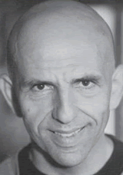
Name: Robert Downey
Age: 45
Height: 5'7
Weight: 190 lbs

Name: Eva Longori
Age: 55
Height: 5'8
Weight: 140 lbs

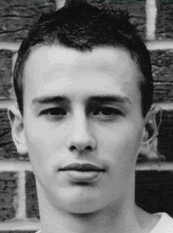
Name: Sara Munchausen
Age: 21
Height: 5'0
Weight: 105 lbs

Name: Jamie Matthews
Age: 18
Height: 6'2
Weight:190 lbs
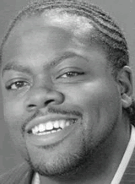

Name: Neil Baxter
Age: 22
Height: 6'1
Weight: 210 lbs

Step 4 - Determining Age
Each of the skulls from the subjects were examined in detail. See if you can determine their age (either over 35 or under 35) by the sagittal sutures. Remember that sutures close fully by the age of 35.
Skeleton 1
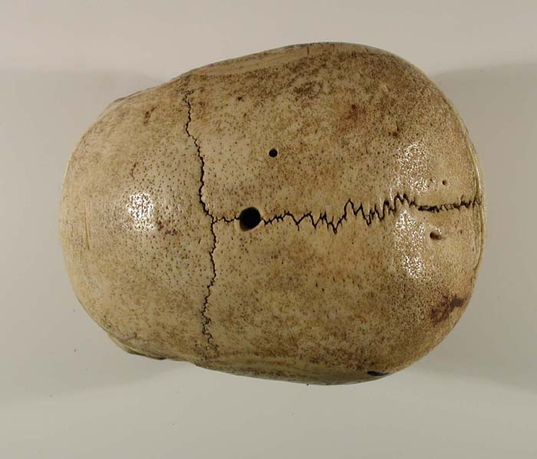
Skeleton 2
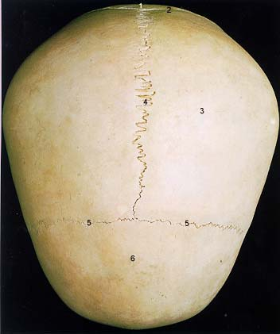

Skeleton 3
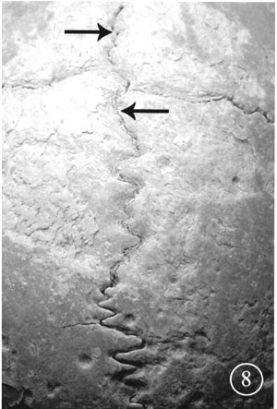

Skeleton 4
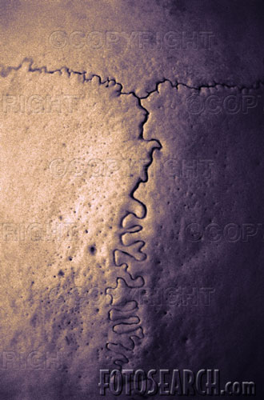

On your skeleton reconstruction page, note whether the skull indicates the person is over 35, or under 35.

Step 5 - Facial Reconstruction
For this part of your investigation, you have sent your skull to the forensic artist who has made a clay sculpture to estimate what your skeleton looked like. Below are the results.

Skeleton 1
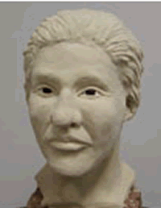
Skeleton 2
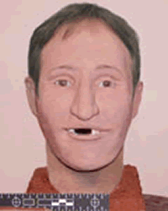

Skeleton 3
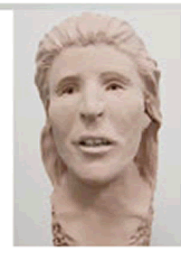
Skeleton 4
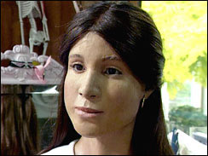

Indicate on your skeleton reconstruction page whether the forensic artist's sculptures match your idea of the skeleton's identity.

